# PHYS 103 lab 9 “Solar System Walk”

**Group name:**………………………………………….…………………………

**Partners’ names:**………………………………………..…………………...........

……………………………………………………………...........

**Background:**

You might have seen scale models of one kind or another. Model airplanes and cars, floor plans for buildings, and maps are examples. An intriguing model in astronomy is a scaled model of the solar system to give people a feel for the relative size and distances of planets.

In today’s lab you will scale the distances from the Sun to the planets so that the whole scale model will fit in a space you choose on campus. Once you know the length of the path where you plan to put your model, you will need to develop a scaling factor.

……………………………………………………………...........

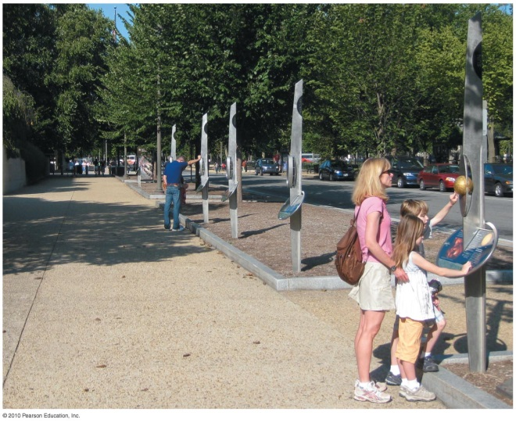

**Figure 1.**

Since the maximum space you have to work with will be the scaled distance between the Sun and Neptune, use the model length divided by the actually distance from the Sun to Neptune to make a ratio which will then be the scaling factor for all the other distances and diameters.

$$Scaling factor = \frac{Distance in model between Sun and Neptune}{Actual distance between Sun and Neptune}$$

**a)**  Is the scaling factor a very large number or a very small one? Why?

**Procedure:**

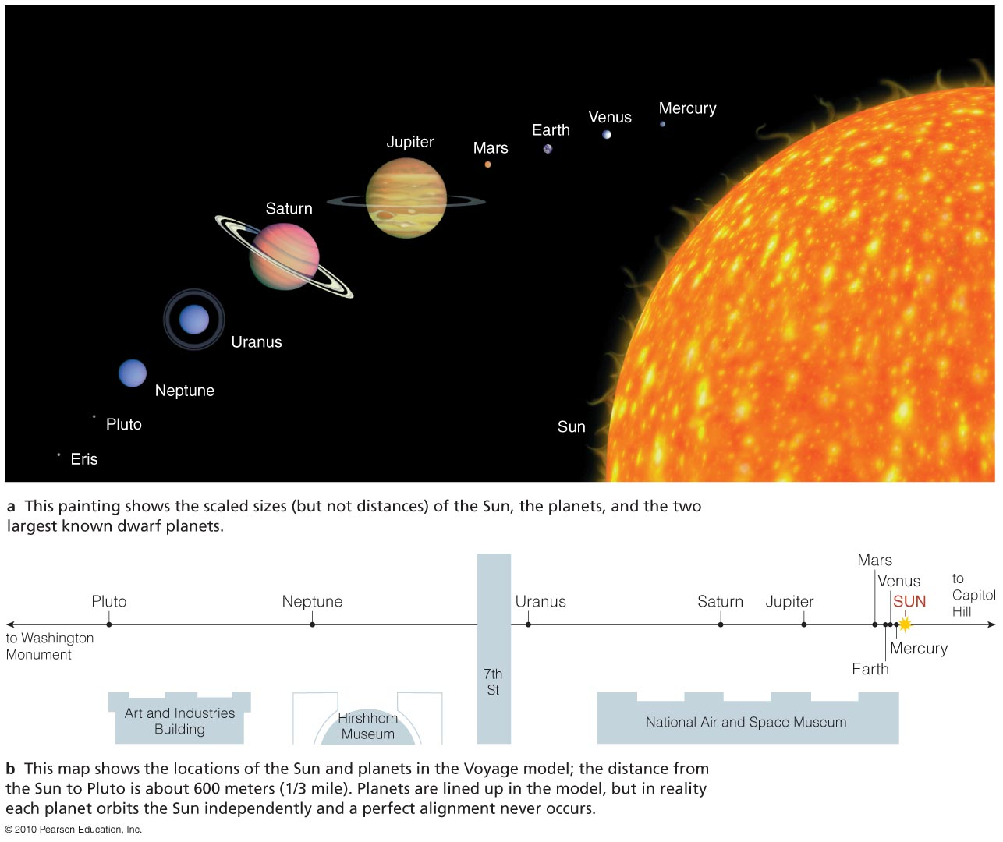

**Figure 2.**

**Scale the model:**

The table of planetary data gives the diameter of each of the planets and their distance from the Sun. Use that data to find the distances and sizes of the objects in your scaled model. Adjust the scaling factor as needed in order to ensure that you can complete the walk, but at the same time that you can find objects in the lab that can represent the sizes of the scaled down planets.

**b)** What is the distance between Sun and Earth for your scaled model?

**c)**  What is the diameter of Earth in your scaled model?

**d)** What is the diameter of Jupiter in your scaled model?

When your table is complete have your instructor check it, then choose the objects that are to represent the Sun and planets. Tape these objects to the index cards with the object’s name. Attach each index card to a skewer that will allow you to place them in the ground. **Lay the skewers on the table and show them to your instructor for approval. Do not head out until your instructor approves your choices.**

**Determine model location:**

An excellent resource for getting an estimate of distances on campus is at the google maps website: <https://www.google.com/maps>. Go to their website, search for GMU Fairfax campus and choose the satellite view. Pick a location for the starting point for your model of the solar system, i.e. where you place the Sun. Then plan your walk. You can measure distances on Google Maps by left-clicking on the map (a point will appear marked if you do it twice), and then right click on that point again, choose “measure distance” from the drop down menu, and left-click at the end point (Neptune’s location). A small window will open at the bottom of the screen giving you the distance between the two selected points in feet and in meters. Compare this measurement with the planned size of your model and adjust as needed. Both points can be moved if you left click and drag them. Left-clicking again removes both points, or, if you find that your selection needs changing, you can also right-click on a point again and select: “clear measurement”. Ideally, the whole model would follow a straight path, but that may not be possible on our campus; still, try to avoid any major turns along your walk.

**e)**  Our scale model begins at……………………………………………………………………………………………………………….

and ends at……………………………………………………………………………………………………………………………………………

and it is ……………………………………………………………… meters long.

We chose this site because

You will need to know how to determine where to place the objects. One possibility is to measure the length of a long step for someone in your group and have that person pace out the distances. Perfect accuracy is not necessary; the goal here is to get a sense of relative size, so the most important thing is consistency. **It will be helpful to convert the distances you need to walk into the number of steps so that you don’t need to do any calculations when you are out walking the path for the model.**

**Build the model:**

Take the stakes with the planet cards and go to your selected site. Pace off the appropriate distances and put a stake where it will not damage plants or structures. Carefully note where you put each of the solar system objects.

Use your camera to take pictures and videos at points along the walk. Try to show as many objects together in a single image as possible – insufficient documentation may cost you points: your instructor needs to be able to gauge if you built your model correctly, so make sure to provide enough evidence. Show familiar sites in the background so your instructor can verify where you were (e.g. in front of Planetary Hall you may be able to show entrance or the sign). Upon returning to the lab, show your instructor your pictures/videos, so he or she can determine if you built your model correctly.

**The model was built correctly:**

*this is the checkbox for your instructor (do not fill it yourself)……………………………………………*

When you have completed the walk go back and **pick up the objects and return them to the lab.** Please remove the objects and sticks from the cards and put them back neatly for others to use. Discard the cards and the skewer sticks.

**Conclusion:**

**f)** What was most interesting to your group about the model you built? Describe your impressions for today’s lab. What, if anything, surprised you and what did you learn in this lab?

**g)** There are three images in the worksheet under tab “pictures”. Are they good depictions of our Solar System? Why or why not? Discuss the merits and shortcomings of each.

Fill in, print and attach your Excel worksheet to this report. Do not print the pictures from the worksheet.